CSE520
Samuel Marrujo
Professor Yu
Homework 3

Homework 3

In this homework, we are to create a tetrahedron that rotates and changes color as time passes. Also, we are to create a cube that uses textures for each face. I have successfully completed this task to the best of my ability for the time presented, and here are pictures of the following:

Each picture will be on a separate page as shown below.
Also, I named the android project Homework 2, not realizing it is Homework 3. This is because this is the second homework we've done on Android.
#1:

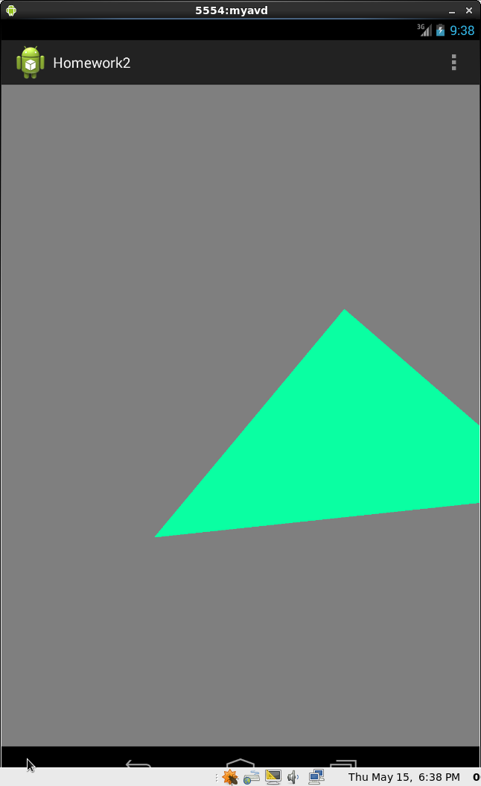
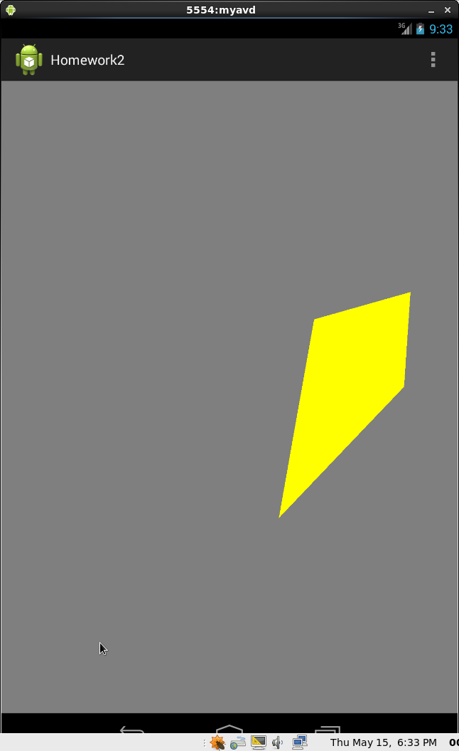
#2:
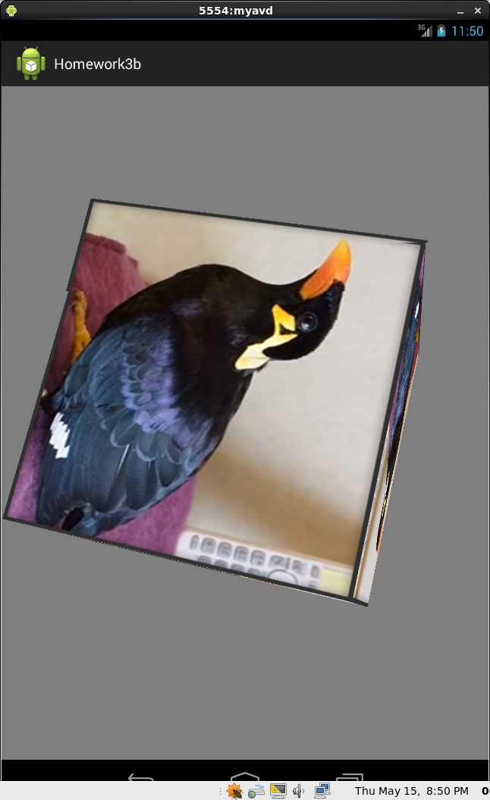
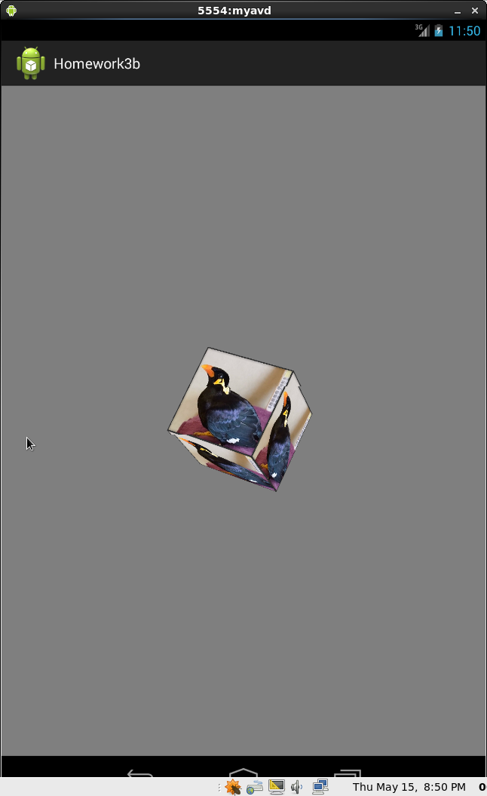
Code:
Used 4 triangles to create a tetrahedron
#1:
package opengles.homework2;

import java.nio.ByteBuffer;
import java.nio.ByteOrder;
import java.nio.FloatBuffer;

import java.io.IOException;
import java.io.InputStream;

import android.app.Activity;
import android.app.ActionBar;
import android.app.Fragment;
import android.content.Context;
import android.os.Bundle;
import android.view.LayoutInflater;
import android.view.Menu;
import android.view.MenuItem;
import android.view.View;
import android.view.ViewGroup;
import android.os.Build;

import android.util.Log;
import android.widget.EditText;

import android.opengl.GLES20;

public class Triangle {
// Source code of vertex shader
private static String LOG_APP_TAG = "tag";
private String vertexshaderCode = null;
private String fragmentshaderCode = null;

private int program;
private int vertexShader;
private int fragmentShader;
private FloatBuffer vertexBuffer1;
private FloatBuffer vertexBuffer2;
private FloatBuffer vertexBuffer3;
private FloatBuffer vertexBuffer4;
private int vertexCount = 3;
private Context context;

// number of coordinates per vertex in this array
static final int COORDS_PER_VERTEX = 3;
static float triangleCoords1[] = { // in counterclockwise order:
0.25f, 0.25f, 0.5f, // top right vertex
-0.25f, -0.25f, 0.5f, // bottom left
0.25f, 0.0f, 1.0f // bottom right
};
static float triangleCoords2[] = { // in counterclockwise order:
0.25f, 0.25f, 0.5f, // top right vertex
0.75f, -0.25f, 0.5f, // bottom left
0.25f, 0.0f, 1.0f // bottom right
};
static float triangleCoords3[] = { // in counterclockwise order:
0.25f, 0.0f, 1.0f, // top right vertex
-0.25f, -0.25f, 0.5f, // bottom left
0.75f, -0.25f, 0.5f // bottom right
};
static float triangleCoords4[] = { // in counterclockwise order:
0.75f, -0.25f, 0.5f, // top right vertex
-0.25f, -0.25f, 0.5f, // bottom left
0.25f, 0.25f, 0.5f // bottom right
};
private float deltaT = 0.0f;
// Set color of displaying object
// with red, green, blue and alpha (opacity) values
float color[] = { 0.0f, 1.0f, 0.0f, 1.0f };
float color2[] = { 1.0f, 0.0f, 0.0f, 1.0f };

// Create a Triangle object
Triangle( Context context0 ){
// create empty OpenGL ES Program, load, attach, and link shaders
context = context0;
vertexshaderCode = getVertexShaderCode();
fragmentshaderCode = getFragmentShaderCode();
program = GLES20.glCreateProgram();
vertexShader = loadShader(GLES20.GL_VERTEX_SHADER, vertexshaderCode);
fragmentShader = loadShader(GLES20.GL_FRAGMENT_SHADER, fragmentshaderCode);
GLES20.glAttachShader ( program, vertexShader );// add the vertex shader to program
GLES20.glAttachShader(program, fragmentShader); // add the fragment shader to program
GLES20.glLinkProgram(program); // creates OpenGL ES program executables
GLES20.glUseProgram( program); // use shader program

// initialize vertex byte buffer for shape coordinates with parameters
// (number of coordinate values * 4 bytes per float)
// use the device hardware's native byte order
ByteBuffer bb1 = ByteBuffer.allocateDirect( triangleCoords1.length * 4);
bb1.order(ByteOrder.nativeOrder());
ByteBuffer bb2 = ByteBuffer.allocateDirect( triangleCoords2.length * 4);
bb2.order(ByteOrder.nativeOrder());
ByteBuffer bb3 = ByteBuffer.allocateDirect( triangleCoords3.length * 4);
bb3.order(ByteOrder.nativeOrder());
ByteBuffer bb4 = ByteBuffer.allocateDirect( triangleCoords4.length * 4);
bb4.order(ByteOrder.nativeOrder());
// create a floating point buffer from the ByteBuffer
vertexBuffer1 = bb1.asFloatBuffer();
vertexBuffer2 = bb2.asFloatBuffer();
vertexBuffer3 = bb3.asFloatBuffer();
vertexBuffer4 = bb4.asFloatBuffer();
// add the coordinates to the FloatBuffer
vertexBuffer1.put(triangleCoords1);
vertexBuffer2.put(triangleCoords2);
vertexBuffer3.put(triangleCoords3);
vertexBuffer4.put(triangleCoords4);
// set the buffer to read the first coordinate
vertexBuffer1.position(0);
vertexBuffer2.position(0);
vertexBuffer3.position(0);
vertexBuffer4.position(0);
} //Triangle Constructor

protected String getVertexShaderCode()
{
InputStream inputStream = null;
String str = null;
try {
inputStream = context.getResources().openRawResource(R.raw.vshader);
byte[] reader = new byte[inputStream.available()];;
while (inputStream.read(reader) != -1) {}
str = new String ( reader );
} catch(IOException e) {
Log.e(LOG_APP_TAG, e.getMessage());
}

return str;
}

protected String getFragmentShaderCode()
{
InputStream inputStream = null;
String str = null;
try {
inputStream = context.getResources().openRawResource(R.raw.fshader);
byte[] reader = new byte[inputStream.available()];;
while (inputStream.read(reader) != -1) {}
str = new String ( reader );
} catch(IOException e) {
Log.e(LOG_APP_TAG, e.getMessage());
}

return str;
}

public static int loadShader (int type, String shaderCode ) {

// create a vertex shader type (GLES20.GL_VERTEX_SHADER)
// or a fragment shader type (GLES20.GL_FRAGMENT_SHADER)
int shader = GLES20.glCreateShader(type);

// pass source code to the shader and compile it
GLES20.glShaderSource(shader, shaderCode);
GLES20.glCompileShader(shader);

return shader;
}
public void draw(float[] mvpMatrix) {
int mMVPMatrixHandle = GLES20.glGetUniformLocation(program, "uMVPMatrix");
GLES20.glUniformMatrix4fv(mMVPMatrixHandle, 1, false, mvpMatrix, 0);
//GLES20.glDrawArrays(GLES20.GL_TRIANGLES, 0, vertexCount);
draw(vertexBuffer1);
draw(vertexBuffer2);
draw(vertexBuffer3);
draw(vertexBuffer4);
}
public void draw( final FloatBuffer coor) {
// Add program to OpenGL ES environment
GLES20.glUseProgram(program);

// get handle to vertex shader's attribute variable vPosition
int positionHandle = GLES20.glGetAttribLocation(program, "vPosition");
int deltaTHandle = GLES20.glGetUniformLocation(program, "deltaT");
// Enable a handle to the triangle vertices
GLES20.glEnableVertexAttribArray(positionHandle);

// Prepare the triangle coordinate data
int vertexStride = 0;
GLES20.glVertexAttribPointer(positionHandle, COORDS_PER_VERTEX,
GLES20.GL_FLOAT, false,
vertexStride, coor);

// get handle to fragment shader's vColor member
int mColorHandle = GLES20.glGetUniformLocation(program, "color");
int mColorHandle2 = GLES20.glGetUniformLocation(program, "color2");

// Set color for drawing the triangle
GLES20.glUniform4fv(mColorHandle, 1, color, 0);
GLES20.glUniform4fv(mColorHandle2, 1, color2, 0);
GLES20.glUniform1f( deltaTHandle, deltaT);
deltaT += 0.1;

// Draw the triangle
GLES20.glDrawArrays(GLES20.GL_TRIANGLES, 0, vertexCount);

// Disable vertex array
GLES20.glDisableVertexAttribArray(positionHandle);
}
}
#2:
package opengles.homework3b;

import javax.microedition.khronos.egl.EGLConfig;
import javax.microedition.khronos.opengles.GL10;
import android.content.Context;
import android.opengl.GLSurfaceView;
import android.opengl.GLU;
/**
* OpenGL Custom renderer used with GLSurfaceView
*/
public class MyRenderer implements GLSurfaceView.Renderer {
Context context;
float scalar = 0.7f;
float change = 0.01f;
int bound = 0;
private Cube cube;
private static float angleCube = 0;
private static float speedCube = -1.5f;
public MyRenderer(Context context) {
this.context = context;
cube = new Cube();
}
@Override
public void onSurfaceCreated(GL10 gl, EGLConfig config) {
gl.glClearColor(0.5f, 0.5f, 0.5f, 1.0f);
gl.glClearDepthf(1.0f);
gl.glEnable(GL10.GL_DEPTH_TEST);
gl.glDepthFunc(GL10.GL_LEQUAL);
gl.glHint(GL10.GL_PERSPECTIVE_CORRECTION_HINT, GL10.GL_NICEST);
gl.glShadeModel(GL10.GL_SMOOTH);
gl.glDisable(GL10.GL_DITHER);
cube.loadTexture(gl, context);
gl.glEnable(GL10.GL_TEXTURE_2D);
}
@Override
public void onSurfaceChanged(GL10 gl, int width, int height) {
if (height == 0) height = 1;
float aspect = (float)width / height;
gl.glViewport(0, 0, width, height);
gl.glMatrixMode(GL10.GL_PROJECTION);
gl.glLoadIdentity();
GLU.gluPerspective(gl, 45, aspect, 0.1f, 100.f);

gl.glMatrixMode(GL10.GL_MODELVIEW);
gl.glLoadIdentity();
}
@Override
public void onDrawFrame(GL10 gl) {
gl.glClear(GL10.GL_COLOR_BUFFER_BIT | GL10.GL_DEPTH_BUFFER_BIT);
gl.glLoadIdentity();
gl.glTranslatef(0.0f, 0.0f, -6.0f);

if ( bound == 0) {
scalar += change;
if (scalar > 1.2f)
bound = 1;
}
else {
scalar -= change ;
if (scalar < 0.3f)
bound = 0;
}
gl.glScalef(scalar, scalar, scalar);
gl.glRotatef(angleCube, 1.0f, 1.0f, 1.0f);
cube.draw(gl);
angleCube += speedCube;
}
}

